Name : Tammie & Vincent Comments :
Group : IDEK

Proposal/Report : Assignment 2 (Collaborative AI)
________________________________________________________________________

Instructions
Create 2 FSMs ( minimum 3 state) each with trigger conditions (no key press) and responses.
Design the FSMs to support or help each other in team play through message boarding.
Each FSM( its object) should send 1 message and respond to 1 message.
Responses can be via HUDs and other forms of notification.

FSM # 1 (Medic)
States
Main:
If There Is No Injured Shooter, Idle.
If There Is An Injured Shooter, Heal The Shooter.

Assistant:
If There Is No Injured Shooter, Idle.
If There Is No Second Injured Shooter, Help Main Medic.
If There Is A Second Injured Shooter, Heal The Second Shooter.

Conditions
Main:
If There Is No Injured Shooter, Idle.
If There Is An Injured Shooter, Heal The Shooter.

Assistant:
If There Is No Injured Shooter, Idle.
If There Is No Second Injured Shooter, Help Main Medic.
If There Is A Second Injured Shooter, Heal The Second Shooter.

State Transition Diagram

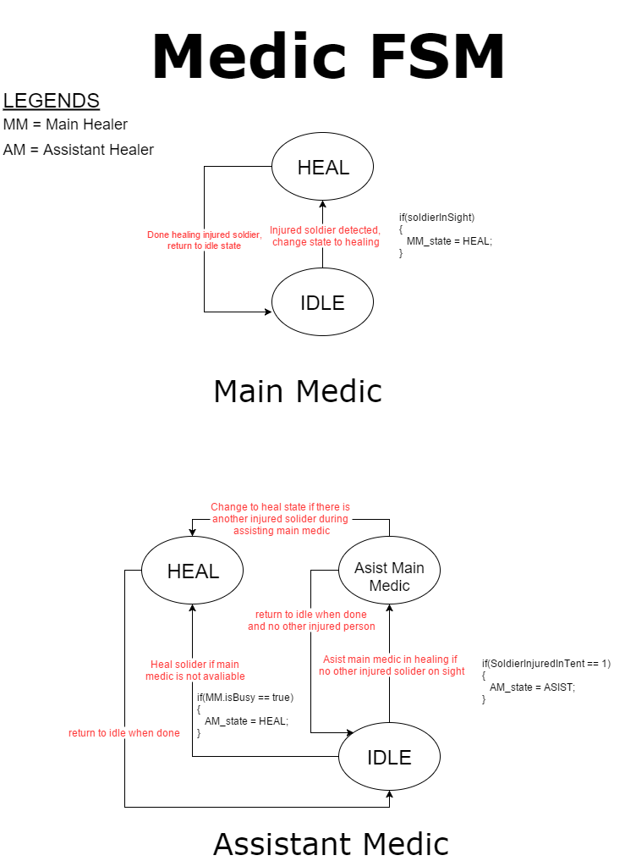

FSM # 2 (Shooter)
States
Main:
If Vampire Is Approaching, Shoot Garlics.
If Vampire Touches Shooter, Retreat To Medic.
If Healed, Return To Previous Position.
If Out Of Health, Die.

Backup:
If Main Shooter Out Of Garlics, Refill Garlics.
If One Main Shooter Injured Or Dead, Replace Shooter.
If Main Shooter Healed, Return To Previous Position.
If Vampire Is Approaching, Shoot Garlics.
If Vampire Touches Shooter, Retreat To Medic.
If Healed, Return To Previous Position.
If Out Of Health, Die.

Conditions
Main:
If Vampire Is Approaching, Shoot Garlics.
If Vampire Touches Shooter, Retreat To Medic.
If Healed, Return To Previous Position.
If Out Of Health, Die.

Backup:
If Main Shooter Out Of Garlics, Refill Garlics.
If One Main Shooter Injured Or Dead, Replace Shooter.
If Main Shooter Healed, Return To Previous Position.
If Vampire Is Approaching, Shoot Garlics.
If Vampire Touches Shooter, Retreat To Medic.
If Healed, Return To Previous Position.
If Out Of Health, Die.

State Transition Diagram

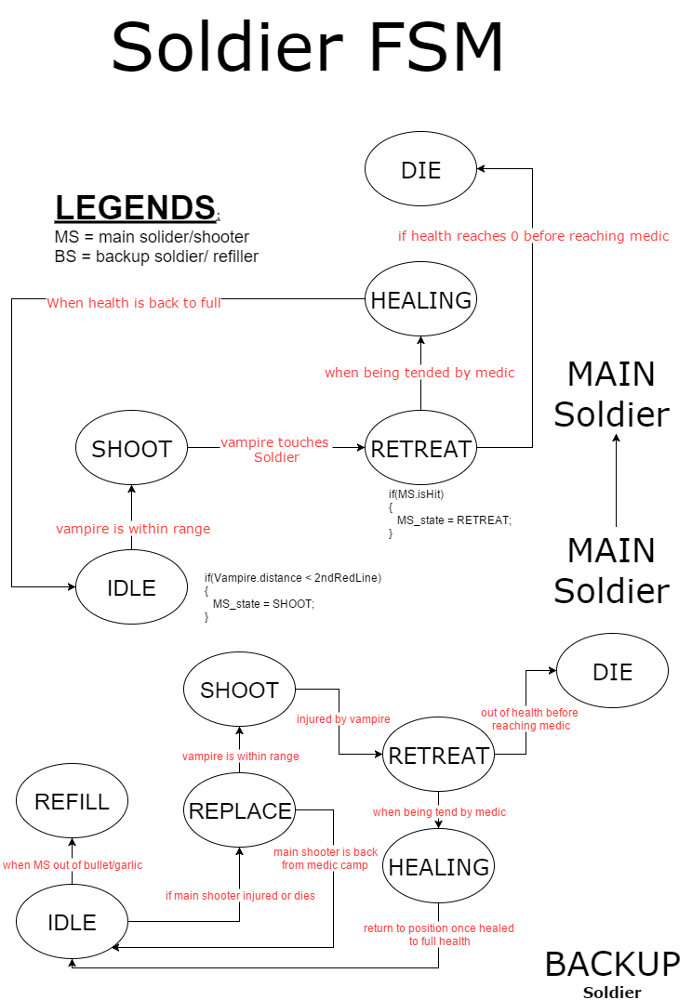

FSM # 3 (Grocer)
States
If Garlic Box Empty, Supply Garlic.
If No Shooter Left, Run Away.

Conditions
If Garlic Box Empty, Supply Garlic.
If No Shooter Left, Run Away.

State Transition Diagram

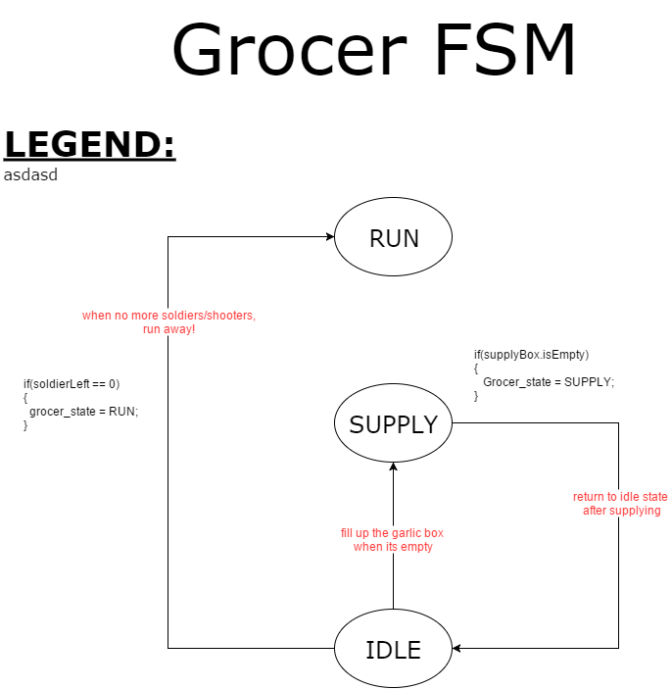

FSM # 4 (Vampires)
States
If Touches First Line, Move Towards Nearest Shooter.
If Touches Second Line And There Is Shooter In Lane, Stay In Lane.
If Touches Second Line And There Is No Shooter In Lane, Change Lane.
If Touches Shooter, Disappear.
If No More Shooter, Destroy Safe House.
If No More Health, Die.

Conditions
If Touches First Line, Move Towards Nearest Shooter.
If Touches Second Line And There Is Shooter In Lane, Stay In Lane.
If Touches Second Line And There Is No Shooter In Lane, Change Lane.
If Touches Shooter, Disappear.
If No More Shooter, Destroy Safe House.
If No More Health, Die.

State Transition Diagram

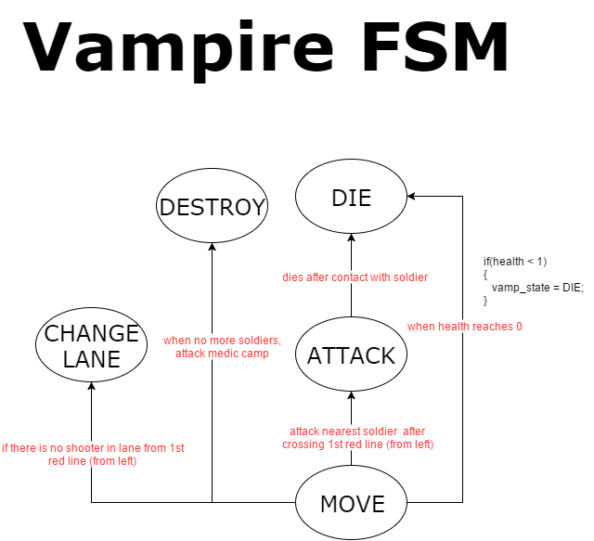

Task List
Tammie
FSM #2 – Shooter
FSM #3 - Grocer

Vincent
FSM #1 - Medic
FSM #4 - Vampire

Together
Link Medic With Shooter
Link Shooter With Vampire

Message Board

Text | Role | From | To | Response | Remarks
“I’ll Take Over The Second Patient!” | Assistant  Medic | Assistant Medic | Main Medic | Heals Second Patient.
“I’ll Help You Out!” | Assistant Medic | Main Medic | Assistant Medic | Returns To Being Assistant Medic.
“I’ll Take Over!” | G.Backup | G.Backup | G.Shooter | Goes To Injured Shooter’s Position.
“I’m Retreating! I Need The Medic!” | G.Shooter | G.Shooter | Patient | Goes To Safehouse.
“I’m All Healed!” | G.Shooter | Patient | G.Shooter | Returns To Original Lane.
“I’m Going Back.” | G.Backup | G.Shooter | G.Backup | Returns To Being A Backup

Example layout (subjected to changes*)

